**SIMPLE NOTIFICATION SERVICE**

Amazon SNS (Simple Notification Service) is a web service that makes it easy to send notifications from cloud.

It provides users with high scalable, flexible, and cost-effective capability to publish messages and immediately deliver them to subscribers

SNS allows you to group multiple recipients using topics. A topic is an “access point” for allowing recipients to dynamically subscribe for identical copies of the same notification

Besides publishing cloud notifications directly to mobile devices, SNS can also deliver notifications by SMS text message or email or any end point

To prevent messages from being lost, all messages published to SNS are stored redundantly across multiple availability zones

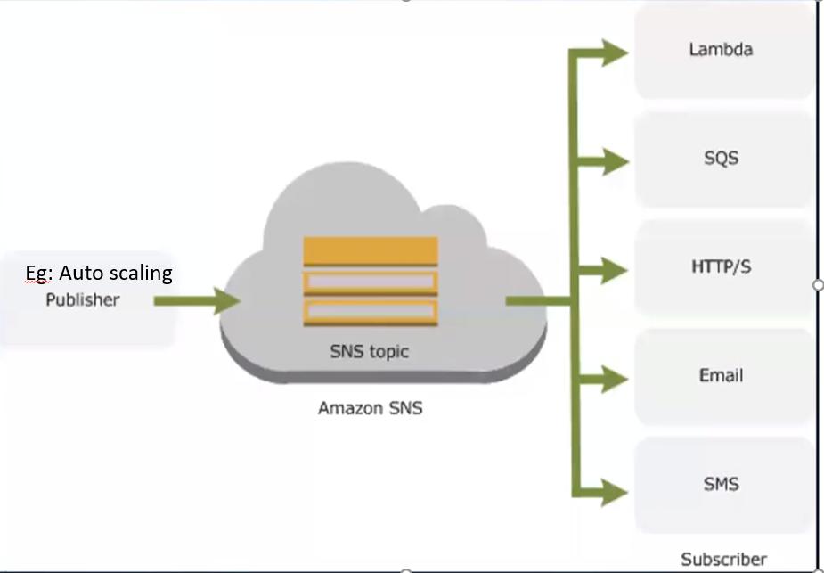

**Benefits**

Instantaneous, push based delivery (No pooling)

Flexible message delivery over multiple transport protocols

Inexpensive, pay-as-you-go model with no up-front costs

Web-based AWS Management Console offers the simplicity of point-and-click interface

SNS – Push based

SQS – Pull based

Both Messaging services in AWS

**1.Create Topic**

When auto scaling launches new machine, we need notification.

In route53, failover routing policy, one region is down, we need notification.

We can receive the notification by using SNS

**Amazon SNS 🡪 Topics**

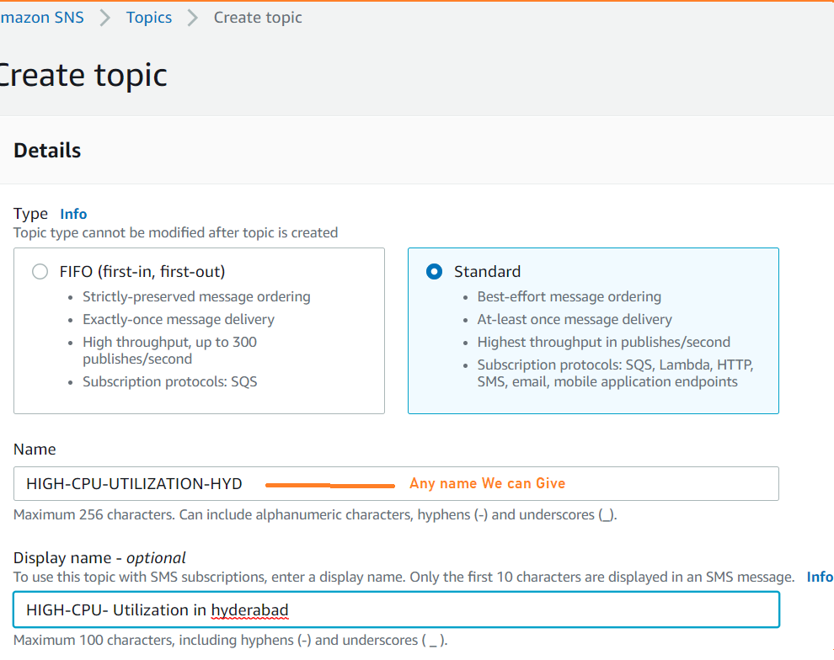

Display name 🡪Email Subject name



when each message content is unique, you can enable **content-based deduplication** for the SNS FIFO topic, and omit the message deduplication ID in your message.

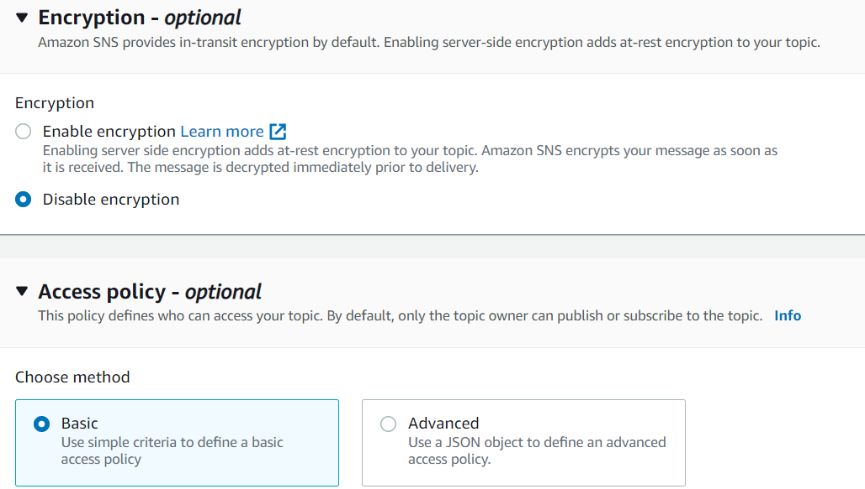

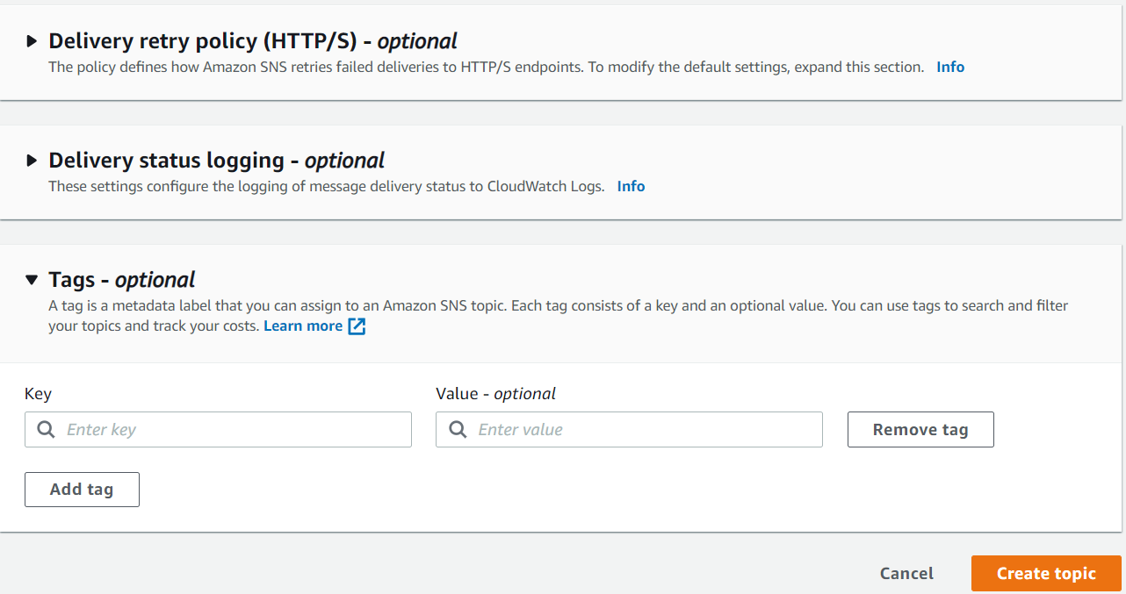

**Define who can publish messages to the topic (under Access policy -optional)**

1.Only the topic owner (Only the owner of the topic can publish to the topic)

2.Everyone (Anybody can publish)

3.Only the specified AWS account

(Only the specified AWS account IDs can publish to the topic)

**Define who can subscribe to the topic**

1.Only the topic owner (Only the owner of the topic can publish to the topic)

2.Everyone (Anybody can publish)

3.Only the specified AWS account

(Only the specified AW S account IDs can publish to the topic)

*4.Only requesters with certain endpoints*

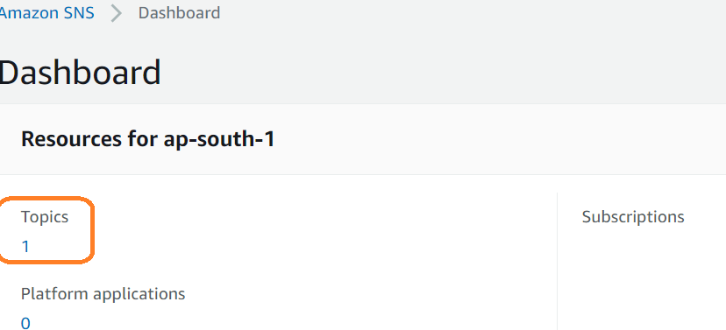

Create **subscription**

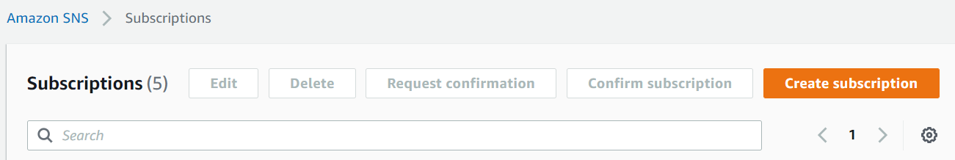

**Subscribers** 🡪 Are nothing but users.

We add email address of subscribers into the group.

The process of adding subscribers to the group, is called subscription.

**Notifications we can receive through (Protocol)**

* Amazon Kinesis Data Firehose
* Amazon SQS
* Amazon Lambda
* Email
* Email-JSON
* HTTP
* HTTPS
* Platform application endpoint
* SMS

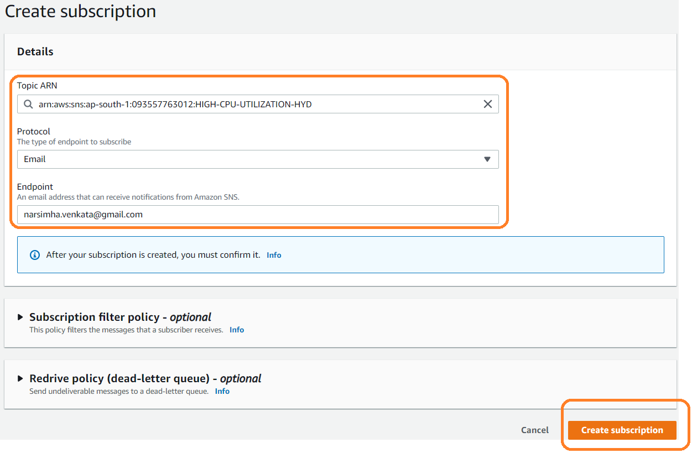

**Observation**: Status as **pending confirmation.**

After subscription we must confirm

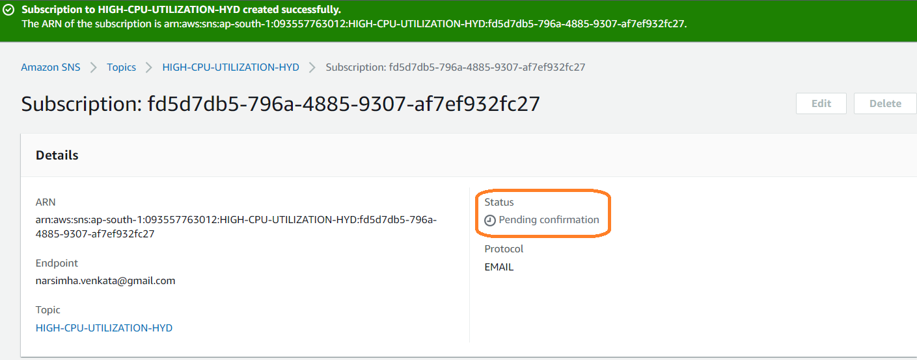

When the status is confirmed?

We need to login to email and accept the email.

We will get email with subject – *“****AWS Notification - Subscription Confirmation****”*

Confirm the subscription.

Now, go to SNS and refresh

**Observation**: Status as ***confirmed.***

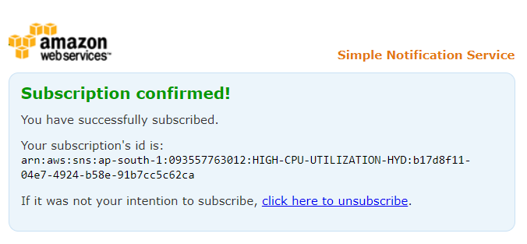

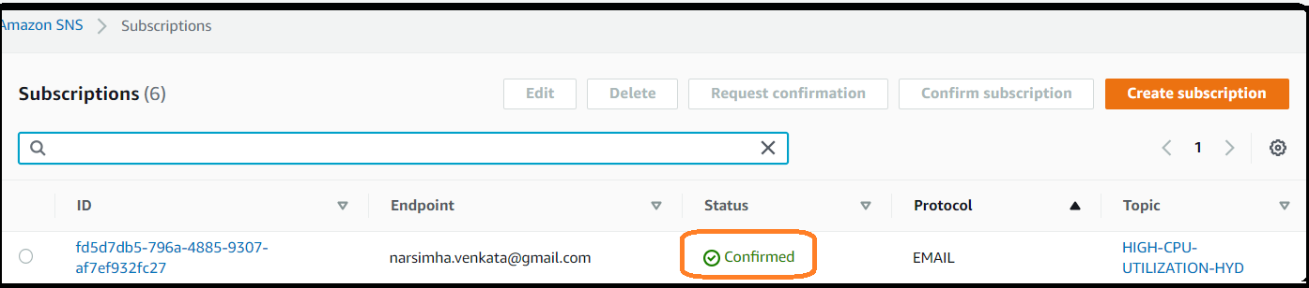

Now, we can integrate this SNS with respect to Autoscaling and all AWS services

**Deleting process**

1.First delete subscription

2.Delete Topic